TWO MARKS QUESTIONS AND ANSWERS
UNIT-1
1.What is data structure?
A data structure is a way of organizing data that considers not only the items stored, but also their relationship to each other. Advance knowledge about the relationship between data items allows designing of efficient algorithms for the manipulation of data.

2.What are types are of data structure?
It is classified into two types.
- Primary Data Structure
- Constant
- Pointer
- Secondary Data Structure
- Static Data Structure
  - Array
  - Structure
- Dynamic Data Structure
  - Linear Data Structure
    - Linked List
  - Non linear Data Structure
    - Tree
    - Graph

3. What is Primary data structure ?
Primary data structures are the basic data structures that directly operate upon the machine instructions. All the basic constants (i.e integers, floating point numbers character constants, string constants) and pointers are considered as primary data structure.

4.Define static data structures
A data structures formed when the number of data items is known in advance is referred as static data structure or fixed size data structure.
Eg. Arrays ,structures.

5. Define dynamic data structures
A data structure formed when the number of data items are not known in advance is known as dynamic data structure or variable size data structure.

6.List some of the dynamic data structures in C.

Some of the dynamic data structures in C refer to linked lists, stacks, queues, trees, etc.

7. Define linear data structure

Linear data structure is data structure having a linear relationship between its adjacent elements. Linked lists are examples of linear data structure.

8. Define non-linear data structure.

Non-linear data structures are data structures that don’t have a linear relationship between its adjacent elements but have a hierarchical relationship between the elements. Trees and graphs are examples of nonlinear data structures.

9.What is algorithm notation?
Algorithm is a step by step procedure to perform a specific task or problem.
It is made up of sequence of clear instructions.

10. What are the properties of algorithm ?
Properties of algorithm :
- Algorithm takes 0 or more input
- Algorithm produces 0 or more output
- Algorithm should be very efficient
- A good algorithm occupy less memory space as much as possible
- The operations can be carried away the finite time.
- A good algorithm can be understood by a non programmer.

11. What are the steps for developing the algorithm ?
The following are the steps to develop the algorithm:
- Device the algorithm
- Validating the algorithm
- Expressing the algorithm
- Determining the complexity of the algorithm

12. Why do we Use a Multidimensional Array?
A multidimensional array can be useful to organize subgroups of data within an array. In addition to organizing data stored in elements of an array, a multidimensional array can store memory addresses of data in a pointer array and an array of pointers.
The syntax is:
DATA TYPE ARRAYNAME [a][b]……….[k];

13. What is an array?
- An array is a fixed size sequence collection of elements of the same data type.
- It is simply a grouping of like type data .
- In its simplest form an array can be used to represent a list of numbers or a list of names.
There are two types of arrays :
- one dimensional array.
- multi dimensional array.

14. Give the syntax for declaring one dimensional array?
The syntax for declaring the array is:

DATATYPE ARRAYNAME[SIZE];
Where ARRAY NAME = name of the array
SIZE = size of the array
Eg: int a[10];
Where a- name of the array
10- size of the array.

15. Give the syntax for two dimensional array?
In case of two dimensional array can store by table of values .
DATA TYPE ARRAYNAME [ROWSIZE] [COLUMNSIZE];
Eg: int a[3][3];
Where int – data type
a- array name
[3]- row size
[3]-column size

16. What is meant by searching and mention its types?
Searching:
- Searching is an operation to find the location of the given data in the array .
- Searching is said to be successful if the data is present otherwise said to be unsuccessful.
- There are three types of searching:
  - Linear search
  - Binary search
  - Fibonacci search
17. What is meant by linear search ?
Linear search is otherwise called as sequential search .
Let a be the array of N numbers and X be the element to be searched .
Our aim is to find whether X is present or not.

18. What is meant by binary search?
Binary search can be implemented using sorted array. It splits the array into two sub arrays.

19.What is meant by time and space complexity ?
The amount of time made by a programmer to perform task is called time complexity .
The space that the algorithm occupies is called as space complexity.

20.What is meant by Fibonacci search ?
The Fibonacci search technique is a method of searching a sorted array using divide and conquer algorithm that narrows down possible locations with the aid of Fibonacci numbers . Compared to binary search, Fibonacci search examines locations whose addresses have lower dispersion.

21. Difference between linear and binary search?
Binary Search | Sequential Search
- It is faster than sequential search. | It is not as fast as binary.
- The elements must be inputed in sorted order. | The elements need not be inputed in sorted order.
- Time complexity is less | Time complexity is more

22. How do you assign an address to an element of a pointer array?
We can assign a memory address to an element of a pointer array by using the address operator, which is the ampersand (&), in an assignment statement such as ptStudents[0] = &marks[2];

23. How to create a program ?
To create an efficient program the following are the steps to be followed :
- Requirements. Make sure you understand the information you are given (the input) and what results you are to produce (the output).
(ii) Design. You may have several data objects (such as a maze, a polynomial, or a list of names). For each object there will be some basic operations to perform on it (such as print the maze, add two polynomials, or find a name in the list). Use a notation which is natural to the way you wish to describe the order of processing.
(iii) Analysis
try to compare these two methods. It may already be possible to tell if one will be more desirable than the other.
(iv) Refinement and coding. You must now choose representations for your data objects (a maze as a two dimensional array of zeros and ones, a polynomial as a one dimensional array of degree and coefficients, a list of names possibly as an array) and write algorithms for each of the operations on these objects.
(v) Verification. Verification consists of three distinct aspects: program proving, testing and debugging
24. What is a variable name?
Variable is the name of the memory area which holds the value or data.
25. What are the rules for naming the variable ?
Rules for naming the variable:
- First character should be a alphabet or underscore(_)
- Special characters are not allowed.
- It should not be as a digit.
- It should not be as a keyword.
- Both uppercase and lowercase are permitted. But they can be treated as different.
- Blank spaces are not allowed.
- There is no limit for identifier length.

26. Give the syntax for the assignment statement ?
Assignment statement:
The assignment statement is indicated by the symbol ← between r.h.s and l.h.s variable
For eg.,
- MAX←A[0]
- I←I+1
- A←B
- I←J←K←0
Statement 1 indicates the value of A[0] is assigned to MAX
Statement 2 is called increment statement.
Statement 3 is called exchange statement. The value of B is assigned to A
Statement 4 is called multiple statements. The value of 0 is assigned to I, J and K

27. Give the syntax for if and if..else statement?
- If statement:
IF(CONDITION)
THEN
STATEMENTS;
First the condition is checked, if it is true, then the statements after ‘THEN’ are executed.
- If else statement
IF(CONDITION)
THEN
STATEMENTS;
ELSE
STATEMENTS;
- First condition is checked, if it true, then the statements after ‘THEN’ are executed.
- If it is false, then else statements are executed.

28. Give the syntax for select case statement ?
Select case statement
SELECT CASE(EXPRESSION)
CASE VALUE 1:
STATEMENTS;
CASE VALUE 2:
STATEMENTS;
.
.
.
CASE VALUE N:
STATEMENTS;
DEFAULT:
STATEMENTS;
- Select case statement is a multiple choice statement.
- The value of expression is matched with all case value.
- When matching occurs, the corresponding case statements are executed.
When no matching occurs, the default statements are executed

29. Give the syntax for Goto statement and exit statement?
Go-to statement
Go-to statement is used to transfer the control from one part of the program to another.
GOTO VARIABLE NAME;
.
.
.
VARIABLE NAME:
STATEMENTS;
Exit statement:
Exit statement is used for immediate termination of the control.
IF(I<10)
EXIT
30. Give the syntax for the repeat statement ?
Repeat statement:
Repeat statement is mostly used in looping.
The general form of repeat statement is

- REPEAT FOR INDEX=SEQUENCE
Where index = valid variable name
Sequence = representation of sequence of nos.
This statement is used to execute the steps for the counted no. of times.
For eg., REPEAT FOR I=0,1,2,…….N
- REPEAT WHILE LOGICAL EXPRESSION
This statement is used to execute the steps until the condition false.
Eg., REPEAT WHILE TRUE
READ A[I]
- REPEAT FOR INDEX=SEQUENCE WHILE LOGICAL EXPRESSION
This statement is the combination of i and ii
This statement is used to execute the steps for a counted no. of items until the expression fails.
UNIT-2
- What is Stack?
- Stack is a linear and static data structure.
- Stack is an ordered collection of elements in which we can insert and delete the elements at one end called Top.
- Initial condition of the stack Top=-1.
- It is otherwise called as LIFO (Last In First Out).

- What are the various operations that can be performed on stack?
In Stack, we can perform two operations namely Push and Pop.
Push: Push means inserting a new element into the stack. Insertion can be done by incrementing top by 1.
Pop: Pop means deleting an element from the stack. Deletion can be done by decrementing top by 1.
- What do you mean by Top in Stack?
- Top is the pointer which always points the top element of the Stack.
- If Top =-1, then Stack is Empty.
- We can insert a new element into stack by incrementing top by 1.
- We can delete an element from stack by decrementing top by 1.

- What are the applications of Stack?
Some of the applications of Stack are:
- Matching of nested parenthesis in a mathematical expression.
- Conversion of infix to postfix.
- Evaluation of postfix.

- What are the conditions that should be satisfied in the matching of nested parenthesis?
Matching of nested parenthesis should satisfy the following two conditions:
- Number of opening parenthesis should be equal to the number of closing parenthesis.
- The closing parenthesis should be preceded by the matching opening parenthesis.

- Define Expression, Operator and Operand?
Expression: Expression is the collection of operators and operands.
Operator: Operator is the symbol which performs mathematical operations on variables.
Operand: Operand is the constant or variable whose values may be int, real, char.
- What are the various types of operators based on number of Operands?
Based on number of operands, there are three types of operators.
- Unary Operator: Unary operator depends upon only one operand.
- Binary Operator: Binary operator depends upon two operands.
- Ternary Operator: Ternary operator depends upon three operands.

- What are types of Expression?
Expression is classified as three types according to position of operator with respect to the operands. They are:
- Infix: The operator is placed in between two operands. E.g.: A+B.
- Postfix: The operator is placed after the operands. E.g.: AB+.
- Prefix: The operator is placed before the operands. E.g.: +AB.

- What do you mean by Hierarchy of Operators?
The order in which the arithmetic operators are evaluated is called Hierarchy of Operators. There are two types. They are:
- High Level Priority and
- Low Level Priority.

- What is Queue?
- Queue is a linear and static data structure.
- Queue is an ordered collection of elements in which we can insert an element at one end called Rear and delete an element at another end called Front.
- Initial condition of the stack Rear=Front=-1.
- It is otherwise called as FIFO (First In First Out).

- What are the various operations that can be performed on Queue?
In Queue, we can perform two operations namely Insertion and Deletion.
Insertion: Insertion can be done by incrementing Rear by 1.
Deletion: Deletion can be done by incrementing Front by 1.
- What do you mean by Queue empty?
- If Queue has no data, then it is called as Queue Empty.
- Queue may be empty on two conditions.
- Front==Rear==-1 and
- Front==Rear.

- What is Linked list?
- Linked list is a dynamic and linear data structure.
- Linked list is an ordered collection of elements in which each element is referred as a node.
- Each node has two fields namely
- Data field or Information field and
- Address field or Link field. 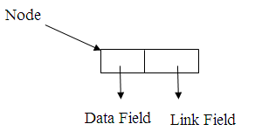

- What are various fields in a Linked list?
Each node has two fields namely
- Data field or Information field and
- Address field or Link field.
Data Field: Data field contains the actual data.
Address Field: Address field contains the address of another node.
- Define Head Pointer?
- Head pointer is the pointer which always points the first node in the list.
- Head pointer holds the address of the first node.
- Using Head pointer only we can move from first node to last node.

- Define External address, Internal address and Null address?
External Address: External address is an address stored in head pointer which holds the address of the first node.
Internal Address: Internal address is an address stored in link field of the each node except the last node.
Null Address: Null address is an address stored in link field of the last node indicates the end of the list.
- What are the types of Linked List?
There are three types of Linked list. They are
- Single Linked list,
- Double Linked list, and
- Circular Linked list.

- What is Single linked list?
- In Single linked list, each node has one link to the next node.
- In Single linked list, we can move from only one direction from head pointer to Null pointer.
- Each node has two fields namely
- Data field or Information field and
- Address field or Link field.
- It is otherwise called as Linear Linked list.
- Consider the following single linked list,
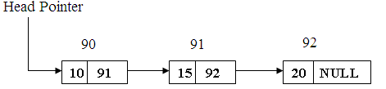

- What is Double Linked list?
- Each node consist of three fields namely
- Previous address field or Backward link field,
- Data field or Information field,
- External address field or Forward link field.
- The previous address field holds the address of the previous node and the next address field holds the address of next node.
- In Double Linked list, we can move in both the direction from head pointer to Null address or vice versa.
- Consider the following linked list, 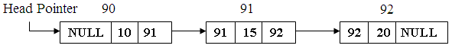

- What is Circular Linked list? Mention its types.
- In Circular linked list, the last node is connected to the first node.
- In Circular Linked list, we can move from head pointer to Null address.
- There are two types of Circular linked list. They are
- Circular Single Linked list and
- Circular Double Linked list.

- What is Circular Single Linked list?
- In Circular Single linked list, the last node is connected to the first node.
- In Circular Single linked list, we can move from only one direction from head pointer to Null pointer
- Consider the following circular single linked list,
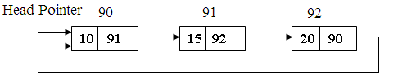
- What is Circular Double Linked list?
- In Circular Double linked list, the last node is connected to the first node.
- In Circular Double Linked list, we can move in both the direction from head pointer to Null address or vice versa.Consider the following circular single linked list, 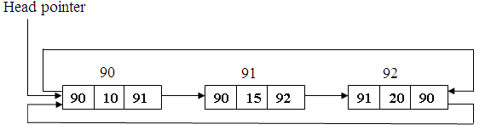

- In how many ways we can insert a node into a single linked list?
We can insert a new node into the list by following positions
- Inserting a node as a first node,
- Inserting a node as a last node and
- Inserting a node as an intermediate node.

- How can we insert a new node as a first node?
- If we want to insert a new node into a single linked list, first we need the empty node with empty data field and empty address field.
- Now store the new element into data field of the new node.
- To insert as a first node, the link field of the new node should replaced by the head pointer.
- Head pointer should replaced by the address of new node.

- How can we insert a new node as a last node?
- If we want to insert a new node into a single linked list, first we need the empty node with empty data field and empty address field.
- Now store the new element into data field of the new node.
- To insert as a last node, the link field of the last node should replaced by the address of new node.
- Link field of the new node should replaced by NULL.

- How can we insert a new node as an intermediate node?
- If we want to insert a new node into a single linked list, first we need the empty node with empty data field and empty address field.
- Now store the new element into data field of the new node.
- To insert as an intermediate node, first we should know the address of the previous node. Then replace the link field of the previous node by the address of new node.
- Replace the link field of new node by the address of successor.
- How does a stack-linked list differ from a linked list?
A stack linked list refers to a stack implemented using a linked list. That is to say, a linked list in which you can only add or remove elements to or from the top of the list.A stack-linked list accesses data last in, first out; a linked list accesses data first in, first out.
- How can you search for data in a linked list?
The only way to search a linked list is with a linear search, because the only way a linked list’s members can be accessed is sequentially. Sometimes it is quicker to take the data from a linked list and store it in a different data structure so that searches can be more efficient.
- List the basic operations carried out in a linked list.
The basic operations carried out in a linked list include.
- Creation of list.
- Insertion of a node.
- Deletion of a node.
- Modification of a node.
- Traversal of the list.

- List the operations other than the basic operations that carried out in a linked list.
The operations other than the basic operations that carried out in a linked list includes
- Searching an element in a list.
- Finding the predecessor element of a node.
- Finding the successor element of a node.
- Appending a linked list to another existing list.
- Splitting a linked list in to two lists.
- Arranging a linked list in ascending or descending order.
- List out the advantages in using a linked list.
The advantages in using a linked list are
- It is not necessary to specify the number if elements in a linked list during its declaration
- Linked list can grow and shrink in size del=pending upon the insertion and deletion that occurs in the list.
- Insertions and deletions at any place in a list can be handled easily and efficiently
- A linked list does not waste any memory space.

- List out the disadvantages in using a linked list.
The advantages in using a linked list
- Searching a particular element in list is difficult and time consuming
- A linked list will use more storage space than an array to store the same number of elements.
- List out the application of a linked list
Some of the important applications of linked lists are
- Manipulation of polynomials,
- Stacks and
- Queues.
- State the difference between arrays and linked list.
Arrays | Linked List
- Size of any arrays is fixed. | - Size of a list is variable.
- It is necessary to specify the number of elements during the declaration. | - It is not necessary to specify the number of elements during the declaration.
- It occupies less memory space than linked list for the same memory number of elements. | - It occupies more memory space.
- State the advantages of using infix notations.
The advantages of using infix notations are
- It is the mathematical way of representing the expression.
- It is easier to see visually which operation is done from first to last.

- State the advantages of using postfix notations.
The advantages of using infix notations are
- We need not worry about the rules of precedence.
- We need to worry about the rules for right to left associatively.
- We need not parenthesis to override the above rules.

- State the rules to be followed during infix to postfix conversions.
The rules to be followed during infix to postfix conversions are
- Fully parenthesize the expression starting from left to right
- Move the operators having higher precedence are first parenthesized
- The part of the expression, which has been converted into post fix, is to be treated as single operand.
- Once the expression is converted into postfix form, remove all parentheses.

- Mention the advantages of representing stacks using linked list than arrays.
The advantages of representing stacks using linked list than arrays are
- It is not necessary to specify the number of elements to be stored in a stack during its declaration.
- Insertions and deletions can be handled easily and efficiently.
- Linked list representation of stacks can grow & shrink in size without wasting the memory space, depending upon the insertion and deletion that occurs in the list.
- Multiple stacks can be represented efficiently using a chain for each stack.

- Define Priority Queue.
- Priority Queue is the ordered collection of elements which are placed on the priority.
- Insertion and deletion are done according to the priority.
- There are two types of Priority Queue. They are
- Ascending Priority Queue and
- Descending Priority Queue.
- Difference between Stack and Queue.
Stack | Queue
- A Stack is an ordered collection of data items, where all insertion and deletions always are made at the end of the sequence called Top. | - A Queue is an ordered collection of items, where all insertions are made at the end of the sequence called Rear and all deletions always are made from the beginning of the sequence called Front.
- In Stack, we get data items out in reverse order compared to the order they have been put into the stack. | - In Queue, we get data items out in same order compared to the order they have been put into the queue.
- Stack is otherwise called as FIFO. | - Queue is otherwise called as FIFO.

- Define Dequeue.
- Dequeue is otherwise called as Double ended queue.
- In Dequeue, we can insert and delete at both ends either front or rear.
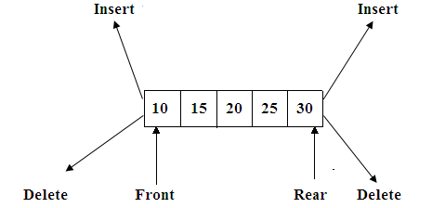

- Define Ascending Priority Queue.
- In this elements are placed in ascending order.
- The first smallest element is placed in first position and second smallest element in second position and so on.
- The new data item is inserted in priority queue without affecting the ascending order of queue.

- Define Descending Priority Queue.

- In this elements are placed in descending order.
- The first highest element is placed in first position and second highest element is placed in second position and so on.
- The new data item is inserted in priority queue without affecting the descending order of queue.

- Define Global Compaction.
- Garbage collection is a process of collecting all unused nodes and returning in available space in garbage collection.
- This process can be carried out in two phases.
- First phase is called marking phase. In this phase all the nodes are marked in case all nodes are in use.
- Second phase collects all the unused nodes and returning them into all available memory space. This phase needs to examine if the nodes are marked or not.

- What is generalized list?
- A generalized list, A, is a finite sequence of n > 0 elements, ₁, ..., _{n} where the _{i} are either atoms or lists.
- The elements _{i}, 1 i n which are not atoms are said to be the sub lists of A.
- The list A itself is written as A = (₁, ..., _{n}). A is the name of the list (₁, ..., _{n}) and n its length.
- By convention, all list names will be represented by capital letters. Lower case letters will be used to represent atoms. If n 1, then ₁ is the head of A while (₂, ..., ₂) is the tail of A.

- Define Input restricted Dequeue.
- It means we can insert the element only at one end and delete the elements at both ends.
- The above diagram shows the input restricted Dequeue.
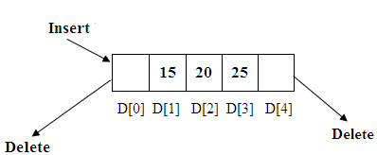

- Define Output restricted Dequeue.
- It means we can insert the elements in both ends and delete the elements at only one end.
- The above diagram shows the output restricted Dequeue.
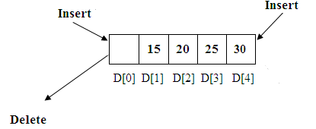

- How to insert at element at the end of the Dequeue.
- First check the Dequeue is full or not.
- We have to check whether the element is first to be added or inserted if it is true assign front and rear is 0.
- Now insert an element.

- How to insert an element at the beginning of the Dequeue.
- First check the Dequeue is full or not.
- We have to check whether the element is first to be inserted if it is true then perform the following steps
  - Shift the elements from left to right
  - So that we need the number of elements present in the Dequeue ,the position of the last element i.e. the position of the rear
  - Now insert any element in zero^{th} position.

- How to delete an element at the beginning of Dequeue.
- Delete the first element from the front position of the Dequeue
- The index of next element is stored in front pointer.
- Increment the front pointer by one.
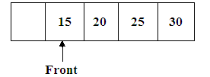
- How to delete an element at the end of Dequeue.
- The last element is deleted.
- The index of next element is stored in rear pointer
- Decrement the rear pointer by one.
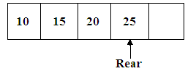

UNIT-3
1.Define tree?
- Tree is a non linear data structure. There is no linear relation between the data items.
- It can be defined as finite set of more than one node.
- There is a special node designated as root node.
- The remaining nodes are partitioned into sub tree of a tree.

The below diagram shows the tree

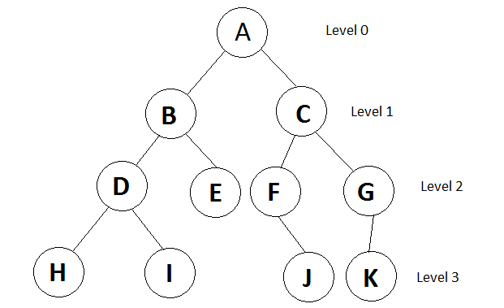
2. Define a path in a tree
The path in a tree is referred as the nodes in which the
successive nodes are connected by the edge in a tree

For eg: the path from A to l
A-B, B-D, D-I.
3.Define terminal nodes in a tree
A node that has no children is called as a terminal node.It is also referred as a leaf node.These nodes have degree has zero.
Define non-terminal nodes in a tree ?
All intermediate nodes that traverse the given tree from its root node to the terminal nodes are referred as non terminal nodes.
6. Define branch ?
Branch or edge of a tree is called as the link or connection between two nodes.
7. Define siblings ?
The nodes having the same parent are called siblings.
8. Define ancestor ?
The ancestor of a node is referred as all nodes along the path of root node to the path node.
9. State the properties of tree ?
- Any node can be the root of the tree.
- If the root is identified; then that tree is called as the rooted node.
- If it is not identified; then that tree is called as the free tree.
- Every node, expect the root node has a unique parent.
10. Define degree ?
The degree of a node is referred as the number of sub-trees of a particular node.
11. Define height of the tree ?
The height or depth of a tree is defined as maximum level of
any node in a tree.
12. Define a binary tree ?
A binary tree is tree, which has nodes either empty or not more than two child nodes each of which may be a leaf node.
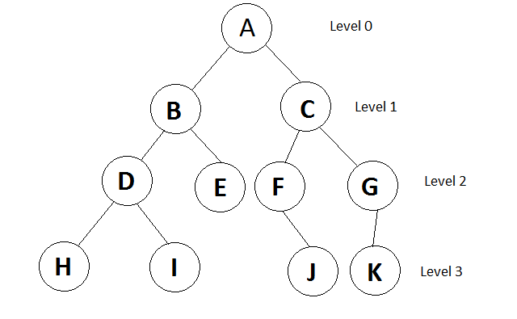

13. Define a full binary tree ?
A full binary tree is a tree in which all the leaves are on the same level and every non-leaf node has exactly two children.
14. Define a complete binary tree ?
A complete binary tree is a tree in which every non-leaf node has exactly two children not necessarily to be on the same level.
15. Define a right skewed binary tree ?
A right skewed binary tree is a tree, which has only right child nodes
16. State the properties of a binary tree.
- The maximum number of nodes on level n of the binary tree is 2^{n-1} where n>=1
- The maximum number of nodes in a binary tree of height n is 2^{n-1} where n>=1
- For any non empty tree n_{l} =n_{d}+1 where n_{l} is the number of leaf nodes and n_{d} is the number of nodes of degree 2.
17. What are the different ways of representing a binary tree?
- Linear representation using arrays
- Linked representation using pointers
18. What is meant by binary tree traversal?
Traversing a binary tree means moving through all the nodes in the binary tree visiting each node in the tree only once.
19. What are the difference binary tree traversal techniques?
- Preorder
- Inorder
- Postorder
20. What are the tasks performed while traversing a binary tree?
- Visiting a node
- Traverse the left sub tree
- Traverse the right subtree
21. What are the tasks performed during preorder traversal?
- Process the root node.
- Traverse the left subtree
- Traverse the right subtree.
22. What are the tasks performed during inorder traversal?
- Traverse the left subtree
- Process the root node.
- Traverse the right subtree
23. What are the tasks performed during postorder traversal?
- Traverse the left subtree
- Traverse the right subtree
- Process the root node.
24. State the merits and demerits of linear representation of binary trees
Merits:
- Storage method is easy and can be easily implemented in arrays
- When the location of a parent /child node is known other one can be determined easily.
- It requires static memory allocation so it is easily implemented in all programming language

Demerits:
- Insertions and deletions in a node, taker an excessive amount of processing time due to data movement up and down the array.

25. State the merits and demerits of linked representation of a binary tree
Merits:
- Insertions and deletions in a node, involves no data movement except the re arrangement of pointers, hence less processing time.
Demerits:
- Given a node structure, it is difficult to determine its parent node.
- Memory spaces are wasted for storing null pointers for the nodes, which have one or no subtrees.
- It requires dynamic memory allocation, which is not possible in some programming languages.
26. Define a binary search tree.
A binary search tree is a special binary tree which s either empty or I it is empty it should satisfy the following characteristics.
- Every node has a value and no two nodes should have the same value.
- The values in any left subtree are less than the value of its parent node.
- The values in any right subtree are greater than the values of its parent node.
- The left and right subtrees of each nod are again binary search trees.
27. What do you mean by general trees
General tree is a tree with nodes having any number of children
27. Define graph
  - A graph consists of two sets V, E.
  - V is a finite and non empty set of vertices.
  - E is a set of pair of vertices, each pair is called an edge.
  - V(G),E(G) represents set of vertices ,set of edges .
    - G= (V,E)
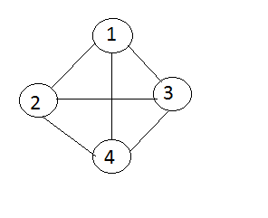
28. Define digraph
If an edge between any two nodes in a graph is directionally oriented, a graph is called as directed .it is also referred as digraph.
29. Define undirected graph.
If an edge between any two nodes in a graph is not directionally oriented, a graph is called as undirected .it is also referred as unqualified graph.
30. Define path in a graph
A path in a graph is defined as a sequence of distinct vertices each adjacent to the next except possibly the first vertex and last vertex is different.
31. Define a cycle in a graph
A cycle is a path containing atleast three vertices such that the starting and the ending vertices are the same.

The cycles are (1, 2, 3, 1) , (1, 2, 3, 4, 5, 3, 1)
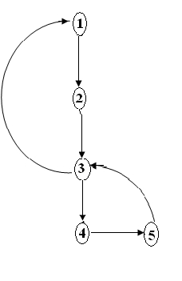
32. Define a strongly connected graph.
A graph is said to be a strongly connected graph, if for every pair of distinct vertices there is a directed path from every vertex to every other vertex. It is also referred as a complete graph.

33. Define a weakly connected graph.
A directed graph is said to be a weakly connected graph if any vertex doesn’t have a directed path to any other vertices.
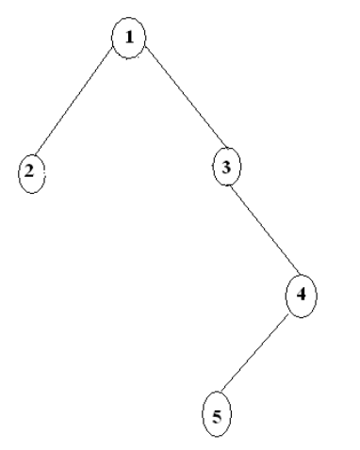
34.Define a weighted graph.
A graph is said to be a weighted graph if every edge in the graph is assigned some weight or value. The weight of an edge is a positive value that may be representing the distance between the vertices or the weights of the edges along the path.
35. How we can represent the graph?
We can represent the graph by three ways
1.adjacent matrix
2.adjacent list
3. adjacent multi list

36.Define adjacency matrix

  - Adjacency matrix is a representation used to represent a graph with zeros and ones.
  - A graph containing n vertices can be represented by a matrix with n rows and n columns.
  - The matrix is formed by storing 1 n its i^{th} and j^{th} column of the matrix, if there exists an edge between ith and jth vertex of the graph and 0 if there is no edge between i^{th} and j^{th} vertex of the graph .
  - Adjacency matrix is also referred as incidence matrix.

37.What is meant by traversing a graph? State the different ways of traversing a graph.
  - In undirected graph ,G=(V,E)
  - The vertex V in V(G)
  - To visit all the vertices that are reached from
the vertex V, that is all the vertices are connected to
vertex V
  - There are to types of graph traversals
1) Depth first search
2) Breadth first search

38.Define depth first search?
  - In DFS ,we don’t have any special vertex ,we can start from any vertex.
  - Let us start from vertex (v),its adjacent vertex is selected and DFS is initialized.
  - Let us consider the adjacent vertices to V are V1, V2, V3 …Vk.
  - Now pick V1 and visit its adjacent vertices then pick V2 and visit the adjacent vertices to continue and process till the nodes are visited.

  - Consider the graph

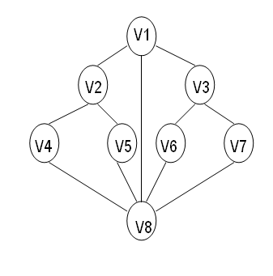

V1 V2, V3, V8
V2 V4, V5
V4 V2, V8
V8 V4, V5, V1, V6, V7
V5 V2, V8
V6 V3, V8
V3 V6, V7, V1
V7 V8, V3

40.Define breadth first search?
- Is BFS ,an adjacent vertex is selected then visit its adjacent vertices then backtrack the unvisited adjacent vertex
- In BFS ,to visit all the vertices of the start vertex ,then visit the unvisited vertices to those adjacent vertices

41.What are the notations used in Evaluation of Arithmetic Expressions using prefix and postfix forms?
Polish and Reverse Polish notations

42.Convert the expression ((A + B) * C - (D - E) ^ (F + G)) to equivalent Prefix and Postfix notations.
Prefix Notation: ^ - * +ABC - DE + FG
Postfix Notation: AB + C * DE - - FG + ^
43.List out few of the Application of tree data-structure?
The list is as follows:
  - The manipulation of Arithmetic expression,
  - Symbol Table construction,
  - Syntax analysis.
44.List out few of the applications that make use of Multilinked Structures?
The applications are listed below:
  - Sparse matrix,
  - Index generation
45.In tree construction which is the suitable efficient data structure?
Linked list is the efficient data structure.

46.Traverse the given tree using Inorder, Preorder and Postorder traversals. 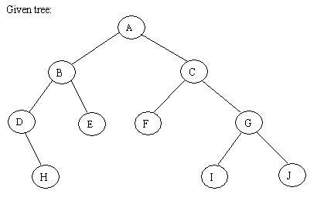
  - Inorder : D H B E A F C I G J
  - Preorder: A B D H E C F G I J
  - Postorder: H D E B F I J G C A
47.What is a spanning Tree?
A tree is a spanning tree of a connected graph G(V,E) such that
  - The edges in T form a tree which includes all the vertices of G
  - Any tree consisting solely of edges in G and including all vertices in G is called spanning tree.

48.Define topological sort?
A directed graph G in which the vertices represent tasks or activities and the edges represent activities to move from one event to another then the task is known as activity on vertex network or AOV-network/pert network
49. Define kruskal ?
Kruskal’s method is an approch to determine a minimum cost spanning of a graph .
In this method we need to select (n-1) edges in G, edge by edge ,such that these form an MST or G.
An edge is included in tree if it does not form a cycle with edges already in T.
50.What is shortest path?
A path having the minimum weight between the vertices.
And the length of a path is the sum of weight of the edges on that path.
51. What are the problems occur in shortest path?
Two kinds of problems in finding shortest path are
- Single source shortest path
- All pair shortest path

52.What is a spanning tree?
A spanning tree is any tree that consists only of edges in a graph G and that includes all the vertices in G.
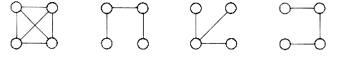
53.What DFS spanning tree?
When either DFS or BFS are used the edges of T form a spanning tree. The spanning tree resulting from a call to DFS is known as a depth first spanning tree.
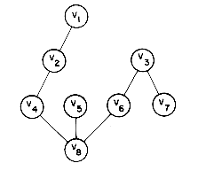

54.What BFS spanning tree?
When either DFS or BFS are used the edges of T form a spanning tree. The spanning tree resulting from a call to BFS is called a breadth first spanning tree.
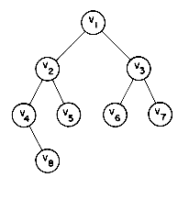
55.What does source and closure mean in shortest paths?
The starting vertex of the path will be referred to as the source and the last vertex the destination.

UNIT-4
- What is Internal Sorting?
- An internal sort is any data sorting process that takes place entirely within the main memory of a computer.
- This is possible whenever the data to be sorted is small enough to all be held in the main memory.
- For sorting larger datasets, it may be necessary to hold only a chunk of data in memory at a time, since it won’t all fit.
- The rest of the data is normally held on some larger, but slower medium, like a hard-disk.

- Define Sorting.
Sorting a group or sequence of elements or data items means rearranging them in either ascending or descending order depending upon the relationship among the data items present in the group.
- What are the factors to be considered while choosing a sorting technique?
The factors to be considered while choosing a sorting technique are
- Programming time
- Running time of the sorting technique
- Number of comparisons required for sorting the list
- Main or auxiliary memory space needed for the sorting technique
- What are the methods available in storing sequential files?
The methods available in storing sequential files are:
  - Straight merging,
  - Natural merging,
  - Polyphase sort,
  - Distribution of Initial runs.
- What is the necessity for sorting technique?
- All data processing requires accessing records efficiently and quickly.
- Search techniques are most efficient only when the data items are sort according to some specified keys.
- If the list/file is not sorted searching a record takes more time when the list/file is large.
- Mention some of sorting techniques.
- Bubble sort
- Insertion sort
- Selection sort
- Shell sort
- Merge sort
- Radix sort
- Quick sort
- Heap sort

- When sorting method is said to be stable?
A sorting method is said to be stable when it has minimum number of swaps i.e. if the two data item of matching value are guaranteed not to be rearranged with respect to each other when the algorithm progresses.
- List out some of the stable and unstable sorting technique.
Stable techniques are:
- Bubble sort
- Insertion sort
- Selection sort
- Merge sort

Unstable techniques are:
- Shell sort
- Radix sort
- Quick sort
- Heap sort

- What is Bubble Sort?
- The idea of bubble sort is to move the highest element to the N^{th} position.
- The principal of bubble sort is to scan the array for N-1 times.
- Bubble sort is otherwise called as Sink Sort.

- Why is the bubble sort called by that name?
The bubble sort derives its name from the fact while sorting the data, the smallest data item bubbles to the initial position of the partially sorted list.
- Why is the bubble sort also called as sinking sort?
Bubble sort also referred as sinking sort derives its name from the fact that while sorting the data the largest data item sinks to the final position of the list.
- Why is the insertion sort called by that name?
The insertion sort derives its name from the fact that while sorting the data each data item is inserted in its correct position among the initially placed data items.
- Is the insertion sort most efficient when the original data are almost in sorted order? Give the reason.
Yes, Insertion sort is the most efficient when the original data are almost in sorted order. Data exchange in insertion sort is minimal when the list to be sorted is in almost sorted order.
- Mention the limitation of insertion sort.
- Insertion sort has the limitation that it compares only the consecutive elements and interchanges the elements by only one space.
- The smaller elements that are far away require many passes through the sort to properly place them in its correct position.
- Why is the selection sort called by that name?
The selection sort devices its name from the fact while sorting the data, it selects the smallest element in the list and swaps with the first element in the list. Then the next smallest element is selected and swapped with the second element in the list and so on until all the elements have been sorted in ascending order.
- How sorting is performed in shell sort?
- First find the smallest element position say I then interchange 0th and Ith position element.
- Then find smallest element say J then interchange first position element and J^{th} position.
- We can repeat the process till N-1 times.
- Finally we can get the sorted array.

- How sorting is performed in shell sort?
The shell sort devices the list into smaller sub lists and then sorts the sub lists separately using the insertion sort by comparing elements that are at a specific distance from each other and swaps the, if necessary.

- Why the shell sort is also called as diminishing increment sort?
Shell sort is also called as diminishing increment sort because the number of elements compared in a list continuously decreases.
- State the advantage of shell sort over insertion sort.
The shell sort overcome the limitation of insertion sort and gains speed ,by comparing elements that are at a specific distance from each other and interchanges them if necessary hence the sorting time is reduced in case of shell sort.
- What is Merge Sort?
- Merging is the process of combining two sorted sub table into single sorted table.
- It can be achieved by finding the smallest element occurring either of the table and place into new table.
- It uses Divide and Conquer rule for its operation.
- Why is the radix sort called by that name?
The radix sort derives its name from the fact that while sorting the data ,it considers the radix of elements from lower order byte to higher order byte and sorts the data items in the list.
- Why the radix sort is also called as bucket sort?
Radix sort is also referred as the bucket sort because the elements to be stored are compared digit by digit and the values are stored into buckets where the index is given by the position of the digit being sorted. Once all digit positions have been examined the list must be sorted.
- How sorting is performed in quick?
- Quick sort divides the initial unsorted list into two parts, such that every element in the first list is less than all the elements present in the second list.
- The procedure is then repeated recursively for both the parts up to relatively short sequence which can be sorted until the sequences reduces to length one.
- What is median-of-three portioning method?
The median of three portioning method is employed in quick sort into find the pivot value. This is done by randomly choosing three elements in the list and finding the median of the elements gives the pivot value.

- Define heap.
A heap is defined to be a complete binary tree with the property that the value of each node is at least as large the value of its child nodes, if they exist. The root node of the heap has the largest value in the tree.
- Why is the heap sort called by that name?
The heap sort derives its name from the fact that while sorting the data, the first step is to store the data in the form of a heap.
27.What is a heap in heap sort?
Heap in heap sort is nothing but the binary tree in which the elements to be sorted are stored.
- What do you mean by max heap?
A max heap referred as descending heap of size n is defined as a complete binary tree of n nodes such that the content of each node is less than to the contents of its parent node.
- What do you mean by min heap?
A min heap referred as ascending heap of size n is defined as a complete binary tree of n nodes such that the content of each node is greater than to the contents of its parent node.
- What do you mean by ternary heap?
A ternary heap of size n is defined as a complete binary tree of n nodes in which the contents of each node is greater than or equal to the contents of all its descendants.
- How sorting is performed in heap sort?
- A heap in a heap sort is nothing but the binary tree in which the elements to be sorted are stored. Then a loop is used to remove each element of the heap.
- When an element is removed it is still part of the list and is swapped with the last item of the heap.
- This process continues and each time the largest item is pushed to the end of the heap, which is directly before the item to be discarded in the previous iteration since the heap becomes smaller.

- Is the heap sort is always better than the quick sort?
No, the heap sort is better than the quick sort when the array is nearly sorted. Since it begins the heap sort algorithm. But if the data is not in sorted order and for well chosen pivots quick sort is much faster than heap sort.

- Which is the fastest sorting technique & why?
As the name indicates the quick sort technique is the fastest sorting technique. The purpose of quick sort is to move a data item in the correct position just enough to reach its final position in the list. This method therefore reduces unnecessary swaps. The quick sort technique has an advantage of moving a data item a great distance in one move to place it in its exact position.
What is Symbol table?
- Symbol table is a data structure it contains the information about the identifier.
- Symbol table have two field
  - Identifier name
  - Memory location
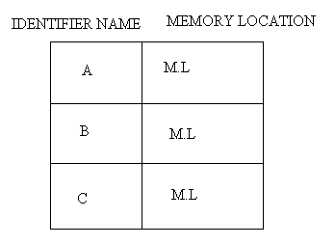
- There are two type of symbol table
- Static tree table
- Dynamic tree table

- What is Hashing function?
If X is an identifier chosen at random from the identifier space, then we want the probability that f(X)=I to be 1/b for all buckets i. then a random has an equal chance of hasting into any of the b buckets. A hash function satisfying this property will be termed a uniform hash function.
Several kinds of uniform hash function are in use.
- Mid-square method,
- Division method,
- Folding method and
- Digit analysis method.
- What is meant by Mid-Square method?
A key is multiplied by itself and the address is obtained by choosing an appropriate number of bits or digits from the middle of the square. The selection of bits or digits based on the table size and also they should fit into one computer word of memory.
E.g.: consider a key, 56789 and when it is squared we get 3224990521. if the three digit address needed, then position 5to7 may chosen, given address 900.
- What is meant by Division Method?
In this method, integer X is to divide by M and d then to use the remainder modulo M. The hash function is
H(x) =x mod M
Great care should be taken while choosing value for M and preferable it should be even number. By making M a large prime number the keys are spread out evenly.
- What is meant by Folding Method?
A key is partitioned into a number of parts, each of which has the same length as the required address. The parts are then added together, ignoring the finial carry, to form an address. For e.g. ., if keys 356942781 is to be transformed into a three-digit address.
Two types:
            - Fold- shifting: 356,942 and 787 are added to yield 079.
            - Fold-boundary method; 653, 942, and 187 are added together, yielding 782.
- What is meant by Digit Analysis Method?
A hashing function referred to as digit analysis forms addresses by selecting and shifting digits or bits of the original key. For e.g., a key 7546123 is transformed to the address 2164 by selecting digits in positions 3to6 and revising their order. Digit positions having the most uniform distributions are selected. This hashing transformation technique has been used in conjunction with static key sets.
- What is meant by open Addressing?
Here, collisions are simply resolved by computing a sequence of hash slots. Two types of techniques:
- Linear probing
- Quadratic probing.
- What is meant by tables?
- Table is a data structure which plays a significant role in information retrieval.
- A set of n distinct records with keys K₁, K₂, …., K_{n} are stored in a file.
- If we want to find a record with a given key value, K.
- The searching time required is directly proportional to the number of number of records in the file.

- Mention some of possible kinds of tables.
Some of possible kinds of tables are given below:
- Rectangular table
- Jagged table
- Inverted table
- Hash tables

- What are the storage classifications?
Storage classifications:
  - Volatile storage: loses contents when power is switched off
  - Non-volatile storage:
    - Contents persist even when power is switched off.
    - Includes secondary and tertiary storage, as well as batter-backed up main-memory.
- What are the Storage Hierarchy?
Storage Hierarchy:
- Primary storage: Fastest media but volatile (cache, main memory).
- Secondary storage: next level in hierarchy, non-volatile, moderately fast access time
  - Also called on-line storage
  - E.g. Flash memory, magnetic disks
- Tertiary storage: lowest level in hierarchy, non-volatile, slow access time
  - Also called off-line storage
  - E.g. Magnetic tape, optical storage
- Write short note on Magnetic-disk.
  - Data is stored on spinning disk, and read/written magnetically
  - Primary medium for the long-term storage of data; typically stores entire database.
  - Data must be moved from disk to main memory for access, and written back for storage
    - Much slower access than main memory (more on this later)
  - direct-access – possible to read data on disk in any order, unlike magnetic tape
- Write short note on Read-write head.
  - Positioned very close to the platter surface (almost touching it).
  - Reads or writes magnetically encoded information.
- Write short notes on MTTF.
Mean time to failure (MTTF) – the average time the disk is expected to run continuously without any failure.
  - Typically 3 to 5 years
  - Probability of failure of new disks is quite low, corresponding to a
“theoretical MTTF” of 30,000 to 1,200,000 hours for a new disk
    - E.g., an MTTF of 1,200,000 hours for a new disk means that given 1000 relatively new disks, on an average one will fail every 1200 hours
  - MTTF decreases as disk ages
- Write short notes on Optical storage.
  - Non-volatile, data is read optically from a spinning disk using a laser
  - CD-ROM (640 MB) and DVD (4.7 to 17 GB) most popular forms
  - Write-one, read-many (WORM) optical disks used for archival storage (CD-R and DVD-R)
  - Multiple write versions also available (CD-RW, DVD-RW, and DVD-RAM)
  - Reads and writes are slower than with magnetic disk
  - Juke-box systems, with large numbers of removable disks, a few drives, and a mechanism for automatic loading/unloading of disks available for storing large volumes of data
- Write short notes on Magnetic Tapes.
- Non-volatile, used primarily for backup (to recover from disk failure), and for archival data.
- Sequential-access – much slower than disk.
- Very high capacity (40 to 300 gb tapes available).
- Hold large volumes of data and provide high transfer rates.
  - Few GB for DAT (Digital Audio Tape) format, 10-40 GB with DLT (Digital Linear Tape) format, 100 GB+ with Ultrium format, and 330 GB with Ampex helical scan format.
  - Transfer rates from few to 10s of MB/s.

- Write short notes on Hash tables.
- Hashing is differs the address or location of identifier is obtained by computing the function f(x).
- It gives address is referred as hash or address of x.
- The memory address refer to hash table (HT) hash table divided in number of buckets.
- HT (0)………………HT (B-1).Each bucket can hold S records.
- Each bucket contain of S slot. Each slot can hold one record.

- Write short notes on Floppy Disks.
- Mylar plastics usually 5 ½ or 8 inches in dia-coating magnetic material.
- 8 to 26 sector/track with 128 to 512 bytes.
- Capacity between 125 KB to 1 MB and transmission rate is 5 to 10 characters/m sec.

UNIT-5
1.What is Binary search tree?
Binary search tree is a 2-way search tree and it is generalized by m-way search tree.
An m-way search is a tree in which in which all nodes are of degree <=m.
2.What is B Tree?
A B Tree of order m is an m-way search tree that is either empty or it satisfies the following properties:
- The root node has atleast 2 children.
- All nodes other than the root node have atleast [m/2] child.
- All failure nodes are at the same level.
3.What are the operations of B Tree?
There are 4 main operations in B Tree
- Searching
- Insertion
- Deletion
- Display all key values
4.What is Upper Bound of Tree?
- A B Tree is always a height balanced tree.
- The degree of B tree of order m is m,that is,the maximum number of branches that can emanate from a node is m.
- In a B tree of order m and height h
The maximum number of nodes possible =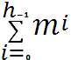=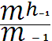
- The maximum number of key values that a node in a B tree of order m can have is m-1.
- The maximum number of key values that is possible in a B tree of order m is :
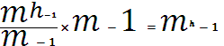

5.What is Lower Bound of B tree?
- The root node contains atleast 2 children.
- All nodes other than the root node can have atleast [m/2] children.
- The minimum number of key values in the root node is 1.
- The minimum number of key value in any node other than the root node is [m/2]-1
6.What is the minimum number of nodes possible at various level?

LEVEL | MINIMUM NO. OF NODES | REMARK
1. | 1 | Root node
2. | 2 | Root node has atleast 2 children
3. | 2x[m/2] | Each node other than the root node has atleast [m/2] children
4. | 2 x [m/2] x [m/2] | .
5. | .
l. | 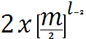 | Minimum number of nodes in the last level.

7.What is B+tree indexing?
A slight modification of indexing in B tree is known as B + tree indexing. B + tree allows redundant storage of key values.
8.What is Trie Tree?
A Trie tree is an m-way search tree. It is a tree of order m either empty or consisting of an ordered sequence of exactly m tries each of order m.
9.What is the application of B tree?
The main application of B Tree is the organization of huge collection of records into a file structure. The organization should be in such a way that any record in it can be searched very efficiently: insertion, deletion, and modification operation can be carried out perfectly and efficiently.
10.What is the application of Trie?
The best application of trie indexing is known in retrievel operation of lexicographic words in a dictionary.
11.Define sequential files
Sequential files have data records stored in a specific sequence. A sequentially organized file may be stored on either a serial-access or a direct-access storage medium.

12.Methods used for transaction logging:
The common method is to use transaction logging this works as follows:
- Collect records for insertion in a transaction file in their order of arrival.
- When population of the transaction file has ceased, sort the transaction file in the order of the key of the primary data file.
- Merge the two files on the basis of the key to get a new copy of the primary sequential file.

13.Whay do you mean by insertion in sequential files?
Records must be inserted at the place dictated by the sequents of the keys. As it is obvious direct insertion in ti the main data file would lead to frequent rebuilding of the file. This problem could be mitigated by reserving overflow areas in the file for insertions. But this leads to wastage of space and also the overflow areas may also be filled
14.Whay do you mean by deletion in sequential files?
Deletion is the reverse process of insertion. The space occupied by the record should be free for use. Usually deletion ( like insertion) is not done immediately. The concerned record (along with a marker or `tombstone’ to indicate deletion) is a transaction file. At the time of merging the corresponding data record will be dropped from the primary data file
15.Whay do you mean by updation in sequential files?
Updation is a combination of insertion and deletions. The record with the new values is inserted and the earlier version deleted. This is also done using transaction files
16.Whay do you mean by retrival in sequential files?
User programs will often retrieve data for viewing prior to making decisions, therefore, is is vital that this data reflects the latest state of the data if the merging activity has not yet taken place.
17.What do you mean by indexed sequential files?
An index in a set of Y, address pairs. A sequential (or sorted on primary keys) file that is indexed is called an index sequential file, The index provides for random access to records, while the sequential nature of the file provides easy access to the subsequent records as well as sequential processing.
18. Define a field.
It is an elementary data item characterized by its size, length and type.
For example: Name: A character type of size 10 ;
Age: A numeric type
19. Define a record.
It is a collection of related fields that can be treated as a unit from an applications point of view.
For example,: A university could use a student’s record with the fields, university enrolment no., name, major subjects.
20. Define an index file.
An index file corresponds to a data file. Its records contain a key field and a pointer to that record of the data file which has the same value of the key field.
The data stored in files is accessed by software which can be divided into the following two categories:

